How it all began

Our Village Hall came to Pulverbatch as the result of vision, good will and hard work by a group of local people after the end of the first World War. The idea was to provide a meeting place or club for the young people returning from the forces and, of course, for the local community.
(I may digress a little, now and then, in order to paint a fuller picture of the characters involved. Forgive me.)

Foundation members were:
Mr and Mrs S Hill, of Lea Farm; parents of the late Tom Hill, ln-Laws-to-be of Nancy, his widow, who now lives there.
Mr and Mrs M Perkins, of Brook Farm; parents of Margaret Pugh who now lives there.
Mr and Mrs J. Morris, of Churton; Bernard’s parents who lived on the site of Dorothy Jones’s present bungalow.
Mr and Mrs W. A. Morris, of Lower New House; parents of the late Jack, In-Laws-to -be of the late Annie. James and Molly Baker and family now live there.
Mr S. Woodcock, of Churton Farms (he ran two). He and his immediate family lived at Lower House, where Tim, Mandy and Freddie Perkins now live. An elderly aunt and uncle lived at the second, Churton House, now inhabited by John and Kate Thorne and family. When the aunt and uncle died, the Woodcocks moved up to Churton House.
Mrs Thatcher, a widow, of The Beeches near Underhill Hall. Later she married Mr Ted Lewis of Castle Farm (on the right, towards The Knapp and now called Castle House), where Phil and Cathy Barton and family now live.
Finally, Mr Briscoe, the Schoolmaster, who acted as secretary to the group.

The women were the driving force behind the venture. (Did I hear “as usual”?). Several menfolk put up £25 apiece and accepted, in good faith, that the money would be repaid by the women’s efforts. To put these loans in perspective. I should point out that farm workers were paid about thirty shillings (£1.50) a week in those days. Although the lenders may not have been labourers, £25 was a substantial sum.
Now, about 1921, there was to be a sale of army huts, thankfully no longer needed, at Prees Heath Camp. It was decided to buy one, for £65, dismantle it and bring it to Pulverbatch. That job was entrusted to Mr. C. Powell and helpers.

Charles or Charlie Powell was our Mary Powell’s father. At one time, he operated a small grain mill on what is now the car park alongside the Woodcock Inn, of which he was Landlord. The mill had a Blackstone engine and the local farmers took their cereals there for grinding, possibly refreshing themselves next door while they waited! In addition, the family had a shop and a bakery, between the Woodcock and the White Horse and would deliver
fresh bread round the village by pony and trap.

Charlie also owned a motor lorry, and it was in this that he and helper(s) set off for Prees Heath. As far as we know, all went reasonably well, but the return journey presented problems. They came down the old A49 as far as Castle Foregate and then found that the high gable ends wouldn’t pass under the railway bridges in town. They had to turn round, somehow, and retrace their route to Harlescott and thence to Ellesmere road and back into town that way and so to Pulverbatch.

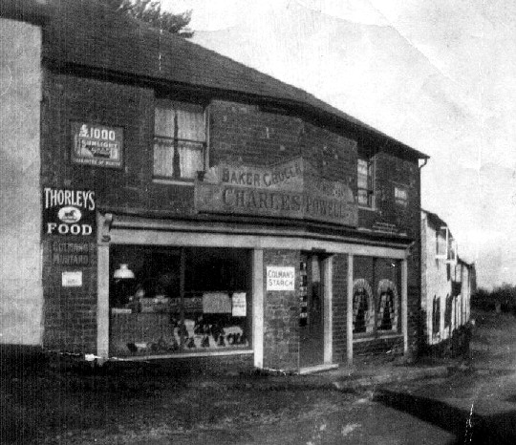
Charles Powell's shop & bakery, with The Woodcock to the far right
Sam Woodcock had donated a small plot of ground for the hut, in a corner of his field opposite the school.
Now enters Mr. Ben Small. He was the local carpenter and wheelwright, a skilled craftsman, who worked at Pulverbatch. He was to oversee the erection of the new acquisition, on site. I imagine many enthusiastic helpers there, proudly re-building the hut, for that’s just what it was, a redundant army hut, but it was their hut, well maintained and preserved, and was expected to last for years.

They mounted it on concrete blocks of eight or nine inches to let the air circulate underneath. It had a wooden roof, which was felted over and they added a modest, galvanised lean-to at the lower end, which housed coal and a small hot-water boiler for washing up. Not that there was any water laid on during those early days, not even a well, they carried it down from the Churton Pump, at the back of Bernard’s family home, a hundred yards or so up the road.

Toilets? There weren’t any of those either, at first. Buckets were used in the ‘Ladies’, but the ‘laddies’ would nip outside to pay a call. The back hedge would be used on light summer evenings but, on dark winter nights, the side hedge was considered discreet enough.
These prices from the old accounts make interesting reading. On the first of March 1923, were purchased:
Item | Cost
Five trestle tables | 6/6d (32.5p) each.
Ten chairs | 8/- (40p) the lot
Ten posher chairs | 2/6d (12.5p) each
Extra chairs and small tables were loaned by committee members and villagers. Many families had a small, folding table, cards being very popular in those days. Few families had a piano, or even one of those increasingly popular wireless sets. Television? - not yet invented in the early twenties.

On the first of October, 1923, a young men’s club opened, boasting about thirty members, to provide an alternative to the pubs. A small billiard table was positioned on one of the trestle tables. There were several games; an airgun and target, a dartboard, dominoes and cards. Modest gambling at cards was overlooked, the stakes being matches. Bernard Morris boasts that he once won five boxes at cards! Whist drives, dances and small, local talent concerts were organised during winters to raise funds.

Charges were as follows: 2/6d (12.5p) for whist and light refreshments, followed by dancing. (beat that!). Alternatively, to dance only, would cost 1/- (5p), with refreshments on sale. There wasn’t any alcohol and music was usually by violin and piano. (I’ll bet that was the same honky-tonk that we still have!)

And so it went on, all in good faith, and the welcome loans were finally repaid. Since those heady, early days, the old army hut has undergone many changes over many years. Succeeding generations and committees had their ideas, made their improvements and additions, so that the building slowly metamorphosed into the fine village hall we have today. Toilets were installed, a large kitchen built, a bar area too, These were added on, not built inside, so that the hail is larger than the original.

Electric lighting came after World War II, when power was led to our outlying villages, as was mains water and therefore luxury flushing toilets. The old boiler and lean-to were removed and an electric hot water geyser installed in the kitchen. The two old coke stoves were replaced by an effective, though noisy, oil-fired warm air heater, replaced in its turn by today’s oil-fired system with radiators and hot water on tap. More land, the Village Hall field, was purchased and part of it turned into the car park.

The Village Hall Committee also has seen changes. Early stalwarts grew older and. having done their bit, stood down to make way for younger members. They, in turn. served their village well for years before handing over the reins. Young or old, however, their enthusiasm and concern for the old place never wavered. Today, with its sturdy metal roof and new heating, rewired, redecorated and with updated, spacious kitchen, it is as good as ever. Long may it continue to act as a friendly, happy venue for our community.

(Postscript. Among the spectators idling and watching Ben Small and team struggle with the re-erection were, no doubt, some of the village boys. One of them was a leggy lad in short pants - Bernard Morris - then about nine years old. He has since seen all the changes and improvements wrought on our Hall over the years and is now one of the respected Elders of our community. Without his delightful reminiscences, this article could not have been written.)

